VERA 8 Little manual

License

VERA and this booklet are covered by the Creative Commons Attribution 4.0 International License: http://creativecommons.org/licenses/by/4.0/ (http://creativecommons.org/licenses/by/4.0/deed.it).

To distribute VERA and this booklet, you need to cite the author (Cesare Gallotti with link to http://www.cesaregallotti.it).

Indice

1 Introduzione 4
2 Valutazione del rischio relativo alla sicurezza delle informazioni 5
2.1 Informazioni e valutazione 5
2.1.1 I campi per censire e valutare le informazioni (e non solo) 5
2.1.2 Note 6
2.1.3 Criteri di valutazione delle informazioni (proposta) 6
2.2 Identificazione e valutazione delle minacce 8
2.2.1 I campi per identificare e valutare le minacce 8
2.2.2 Criteri di valutazione delle minacce (proposta) 9
2.2.3 Aggiungere minacce 10
2.3 Calcolo del livello di rischio 11
2.3.1 Descrizione del calcolo 11
2.3.2 Criteri di accettazione del rischio (proposta) 12
2.4 Identificazione e valutazione dei controlli 13
2.4.1 Campi dei controlli 13
2.4.2 Criteri di valutazione dei controlli di sicurezza (proposta) 13
2.4.3 Aggiungere un controllo 13
3 Trattamento del rischio 15
4 Riesame periodico 16
5 Privacy 17
6 Procedura per descrivere l’approccio 18

Introduction

Risk assessment should be a technique for identifying threats, thinking about the measures that control them, verifying whether or not they are implemented, and then determining what actions to take (in a nutshell: modifying the measures or keeping them as they are).

Information security risk assessment has always been tied to the analysis of checklists and the use of numbers to indicate the level of risk. This is also because it is required, rightly or wrongly, in the context of audits (for current or prospect customers, ISO/IEC 27001 certification or other).

ISO/IEC 27001 also requires a list of the implemented information security controls and in many cases it is convenient to do so following the list proposed by Annex A of the standard itself.

VERA, a spreadsheet for assessing risk, meets these needs, especially in the context of SMEs. It certainly has its limitations, but it has the advantage of drastically reducing configuration and filling times compared to more complex software. Such more complex software, many times, does not yield more meaningful results anyway.

VERA makes it possible to analyze the risk related to information security at a tactical level, i.e. at the level of the process and organization in general. For the operational level, it is better to use more precise analysis tools.

For example, VERA makes it easy to identify deficiencies in the patching process. If you identify a single server that is out of date, it may be more appropriate to record the evaluations and actions resulting from the identification in a change ticket, not in a comprehensive risk assessment such as in VERA.

In 2008, when VERA was born, organizations often started with a complex approach, often linked to expensive and complex software, and "simplified" it, losing consistency or completeness in analysis.

The other side of the coin of ease of use is that good information security skills are required to correctly interpret the data to be entered and the results obtained.

Extensions of VERA
Some, in recent years, have felt the need to expand the lists of threats and controls proposed by VERA. For example, to include threats related to external parties or controls of other standards such as ISO/IEC 27019. This, with a few caveats, is easy to do with VERA.

Others had to analyse multiple areas and therefore used multiple VERA files.

It's up to everyone to take advantage of the flexibility offered by an Excel spreadsheet to build the most suitable approach for the risk assessment.

Relationships with other controls (NIS and others)
Version 8 has, near ISO/IEC 27001 controls, the Impl. reg. 2024/2690 measures for IT providers under NIS2. There are also the NIST CSF 2.0 measures.

I tried, as much as possible, to have, for each Impl. reg. and NIST CSF measure only one ISO/IEC 27001 control. In other words, a one-to-many relationship. Obviously, there are many exceptions.

In version 8 there are no more the ISO/IEC 27001:2013 controls (but still there are level 2 numbers, because I still continue to remember them). Some of the sub-controls, added in version 8 for the cross-reference between 2013 and 2022 versions, have been deleted. Others have been added for having the relationships with Implementing regulation and NIST CSF. I added the ISO/IEC 27001 HLS requirements (chpaters 4-10) for linkage with some of the Impl. reg. and NIST CSF measures.

ISO/IEC 27001 controls are extended with:
- ISO/IEC 27701:2025 (Final draft) controller and processor controls;
- ISO/IEC 27017:2026 (Draft del marzo 2025) extended control set;
- ISO/IEC 27018:2025 (Final draft) extended control set;
- HLS requirements (this is bad from a theoretical point of view, but it can be useful from a practical point of view).

Information security risk assessment

Information and evaluation
The first sheet is the one where the information must be listed and evaluated. The basic fields are indicated below. The others can be used or not used depending on the needs of the organization.

Fields for listing and evaluating information (and more)
The fields are the following ones:
- Organizational unit: the office or group that processes the information. Standards are often “process-based”, but the analyses are naturally done at the level of the organizational unit, i.e. groups of people who carry out activities related to each other (e.g. HR, production, purchasing).
- Information assets [mandatory field]: the level of detail is determined by the person doing the analysis. The important thing is to list all of them, even not precisely. For example, at the HR Office it is possible to identify only 2 large groups of information: personnel administration (payroll, leave records, etc.) and management information (training, evaluation, etc.).
- Processing activities and purposes: why the information is collected and processed;
- Organization role: field for those who want to use the table also as a record of processing of personal data. The values can be: Owner, Joint Controller, Processor, etc.
- Confidentiality, Integrity, Availability [mandatory fields for the calculation of consequences]: value from 1 to 4, to be assigned according to the criteria in the "Criteria for information assets evaluation" tab (they can obviously be modified according to needs). The values are indicated as:
C, I, A
- Notes (justifications): to write the reasons why the values were given.
- MTPD (max time unavailable): How long the information can be unavailable.
- Archives (IT systems, physical archives, other archives): This field is also useful for associating assets with information. If applicable, the life cycle of the data can also be reported here.
- Contact persons: The persons in the organizational unit who helped identify the data entered in the other fields.
- Data subjects: field for those who want to use the table also as a record of personal data processing.
- Types of personal data: field for those who want to use the table also as a record of personal data processing.
- Legal basis for the processing: field for those who want to use the table also as a record of the processing of personal data.
- Suppliers (processors): suppliers to whom data is transmitted for further processing. E.g. email service providers.
- Other recipients: entities to which the data are transmitted, but not suppliers (e.g. Retirement funds, holding company). These fields are free and should be used to improve the analysis.
- Extra EEA: field for those who want to use the table also as a record of personal data processing.
- Retention times: The maximum amount of time the data is retained.

Notes
The overall value of the organization, in terms of confidentiality, integrity, and availability, is given by the maximum of each value assigned to the listed information (the reason is described in my book "Information Security").

For more complex organizations, you can divide your organization into "sub-organizations" and use a VERA sheet for each of them.

Criteria for information assets evaluation (proposal)
The following table is an example and can be changed as needed.

Lev. | C - Confidentiality | I - Integrity | A - Availability
1 - Low | Organization  Information doesn’t have specific confidentiality requirements or is public.  Data subjects  Low consequences (e.g. annoyance) for:  - loss of autonomy;  - exclusion;  - loss of freedom;  - physical damage;  - stigmatization;  - power imbalance;  - loss of trust;  - economical loss. | Organization  Information doesn’t have specific integrity requirements and is not part of economic or financial or health transactions.  Data subjects  Low consequences: annoyance and time for correcting data. | Organization  The unavailability of information doesn’t have economic consequences because they are not linked with SLAs.  Data subjects  Low consequences: annoyance and time for correcting data.
2 - Medium | Organization  Information is confidential for business reasons (e.g. for avoiding competitors advantage or for brand protection) and a loss of confidentiality can have, in the worst case scenario, limited consequences from a financial, regulatory or long term reputation (brand) point of view.  Data subjects  Difficulties (e.g. loss of money, fear, misunderstanding, stress, minor health problems) because of effects on social or personal life in terms of:  - loss of autonomy;  - exclusion;  - loss of freedom;  - physical damage;  - stigmatization;  - power imbalance;  - loss of trust;  - economical loss. | Organization  Information is not part of financial or health transactions. The loss of integrity doesn’t have consequences on operations, regulatory obligations or long term reputation (brand).  Data subjects  Difficulties (e.g. loss of money, fear, misunderstanding, stress, minor health problems) because of effects on social or personal life in terms of:  - loss of autonomy;  - exclusion;  - loss of freedom;  - physical damage;  - stigmatization;  - power imbalance;  - loss of trust;  - economical loss. | Organization  The unavailability of information have limited economic consequences (considering SLAs).  Data subjects  Difficulties (e.g. loss of money, fear, misunderstanding, stress, minor health problems) because of effects on social or personal life in terms of:  - loss of autonomy;  - exclusion;  - loss of freedom;  - physical damage;  - stigmatization;  - power imbalance;  - loss of trust;  - economical loss.
3 - High | OrganizationThe loss of confidentiality, in the worst case scenario, can have high consequences from a financial, market sharing, regulatory and long term reputation (brand) point of view.Data subjectsHigh consequences (e.g. unavailability of money, property damage, loss of work, legal litigations, health damage) that can hardly resolved. | OrganizationInformation is not part of financial or health transactions. The loss of integrity have limited consequences on operations, regulatory obligations or long term reputation (brand).Data subjectsHigh consequences (e.g. unavailability of money, property damage, loss of work, legal litigations, health damage) that can hardly resolved. | OrganizationThe unavailability of information have high economic consequences (considering SLAs).Data subjectsHigh consequences (e.g. unavailability of money, property damage, loss of work, legal litigations, health damage) that can hardly resolved.
4 - Critical | Organization  The loss of confidentiality, in the worst case scenario, can have high consequences from a financial, market sharing, regulatory and long term reputation (brand) point of view. Such consequences can compromise company sustainability.  Data subjects  Irreversible damages on social or personal life. E.g. in terms of:  - loss of autonomy;  - exclusion (inability to work);  - loss of freedom;  - physical damage (e.g. insanity, long term physical issues or death);  - stigmatization;  - power imbalance;  - loss of trust;  - economical loss. | Organization  Two options:  - The loss of integrity can have consequences on regulatory obligations  - The loss of integrity can have consequences on financial transactions, operations, or long term reputation (brand) and this can lead to issues in company sustainability.  Data subjects  Irreversible damages on social or personal life. E.g. in terms of:  - loss of autonomy;  - exclusion (inability to work);  - loss of freedom;  - physical damage (e.g. insanity, long term physical issues or death);  - stigmatization;  - power imbalance;  - loss of trust;  - economical loss. | Organization  The unavailability of information have high economic consequences (considering SLAs) that can compromise company sustainability or can have consequences on health of people.  Data subjects  Irreversible damages on social or personal life. E.g. in terms of:  - loss of autonomy;  - exclusion (inability to work);  - loss of freedom;  - physical damage (e.g. insanity, long term physical issues or death);  - stigmatization;  - power imbalance;  - loss of trust;  - economical loss.

Threat identification and assessment
In the " Threats - Risk" tab, the likelihood of the threats must be assessed.

The proposed threats belong to multiple scopes (column B):
- Information security: these are taken from ISO/IEC 27005 and subsequently reworked on the basis of experience and suggestions from various users. These threats are divided into categories, as suggested by ISO/IEC 27005. However, the "Categories" column is not necessary.
- Privacy: Threats in addition to the above and related to privacy. To assess the risk related to the protection of personal data, it is advisable to use the threats in "SicInfo" and "Privacy" scopes.
- Management system effectiveness: management systems ISO standards promote (as "risks and opportunities" identification) a risk assessment of the management system effectiveness. ISO/IEC 27001 allows these risks to be assessed together or separately from information security risks. VERA allows these risks to be assessed, but, if not deemed necessary, they can be cancelled.
- Criminal responsibilities: Laws such as SOX in USA require to assess certain risks. Some of them can be integrated into the information security risk assessment. VERA offers just one example for those who want to follow this path. Others can simply delete the row.

You can add and remove threats as described below.

Fields for identifying and assessing threats
More fields in the " Threats - Risk" tab are described in section Error: Reference source not found.

The fields on the tab:
- Threat scope: See above.
- Category: see above.
- Likelihood (1-3) [mandatory field]: value from 1 to 3, to be assigned according to the criteria in the "Evaluation criteria" tab, under the heading "Threat evaluation criteria" (they can of course be modified according to needs). The value is indicated as
t.
- Notes: where to enter the justifications for the assigned values of likelihood and consequences (e.g. for the threat "Earthquakes, volcanic eruptions", you can indicate "Low seismic risk area as attested by the www.tuttitalia.it site". There are a few examples.
- CIA parameters (for Sicinfo scope) [mandatory field]: I recommend to not modify the given values for threats that are already present. Indicates whether a threat affects the confidentiality, integrity, or availability of information. This creates a vector (c, i, a) where c, i, a are equal to 0 or 1 depending on whether the threat has consequences on the confidentiality, integrity or availability of the information (on the Excel you have to write C, I or A in the field, which are then used by the formula to calculate the consequences, in the next field).
- Assets: some find these columns useful.
- Consequences: Calculated field. This is the highest value of confidentiality, integrity, or availability, depending on which of these parameters it affects. In terms of formula:
i = MAX (Cxc, Ixi, Axa)
- Pure risk (calculated field, with a minimum of 1 and a maximum of 12). This is a level of risk without considering countermeasures or vulnerabilities. This is not a value that is required for analytics. It is necessary for DPIA, and in fact it is found in the "Privacy Risk" tab, since it is necessary to identify when you have a "high risk in the absence of measures". It is the product of likelihood and consequences:
Pure Risk = MAX (Cxc, Ixi, Axa) ∙ t
- Risk Level per Threat (calculated field): This is the maximum of each risk related to the threat and each control that can counter it. It is calculated after you assign the value to the controls. It is explained below.

Threat likelihood criteria (proposal)

Likelihood assessment criteria

The following table is an example and can be changed as needed.

Lev. | Likelihood criteria
1 - Low | One of the following:  - threat is less likely than in most important information security reports and surveys;  - in case of deliberate attack, information are not important for attackers and brand is not compromised so attacks are not initiated or attackers don't have many resources.  - in case of unintentional attack, the scope is not complex so it is difficult to do mistakes;  - in case of natural events, reports and surveys show that the threat is rare.
2 - Medium | One of the following:  - threat is likely as in most important information security reports and surveys;  - in case of deliberate attack, information are important for attackers and brand is not compromised so attackers don't have many motives, competence, resources; as alternative, public reports say that this threat is unlikely;  - in case of unintentional attack, the scope has a medium complexity so mistakes can be made;  - in case of natural events, reports and surveys show that the threat can happen.
3 - High | One of the following:  - threat is more likely as in most important information security reports and surveys or such surveys say that the attack it is for sure;  - in case of deliberate attack, information are very important for attackers and brand can be compromised so attackers have many motives, competence, resources.  - in case of unintentional attack, the scope has a high complexity (e.g. may sites, types of IT systems, internal or external users) so mistakes are frequent;  - in case of natural events, reports and surveys show that the threat is for sure.

Consequence criteria

VERA can also be used to assess threats that do not affect information security, or in any case are not strictly relevant to it (e.g. continuity threats, management system effectiveness threats). However, these threats can be integrated with the information security ones.

For such threats, the consequences are not determined by the CIA parameters, but must be evaluated separately: in the "CIA parameters" column, nothing should be indicated, so the "Consequences" field must be filled in).

The following table is an example and can be changed as needed.

Lev. | Consequence criteria
1 - Low | The organization will experience few consequences (e.g. annoyance) and no direct or indirect loss of money (e.g. loss of customers).
2 - Medium | The threat has low consequences on the business, on the legal compliance or on the brand.  Consequences are little annoyance in terms of loss of trust from customers or money loss or process inefficiency.
3 - High | The threat has high consequences on the business, on the legal compliance or on the brand.  consequences are actual difficulties in terms of loss of trust from customers or money loss or process inefficiency.
4 - Critical | The threat has critical consequences on the business, on the legal compliance or on the brand.  consequences can compromise the sustainability of the organization because of loss of trust from customers, closure or complete loss of a process or the management system.

Adding threats
There are two types of threats to be added:
- special cases of the threats already listed;
- new threats.

- special cases of the threats already listed

In this case, it is recommended to add details to the threat description.

E.g. if you want to consider ransomware, you can change the threat "Virus (malware, also mobile)" to "Virus (malware, also mobile) and ransomware". The controls to mitigate, detect, and follow it, ultimately, are the same.

New threats

- In the " Threats - Risk" tab, insert a line where you think it is most appropriate.
- Fill in the fields.
  - Mandatory fields are, of course: "Threat", "Likelihood", "CIA parameters".
  - Copy the formulas from another row for the "Consequences", "Pure Risk" and " Risk level for threat" fields. Excel, when copying, should automatically "adjust" the formula.

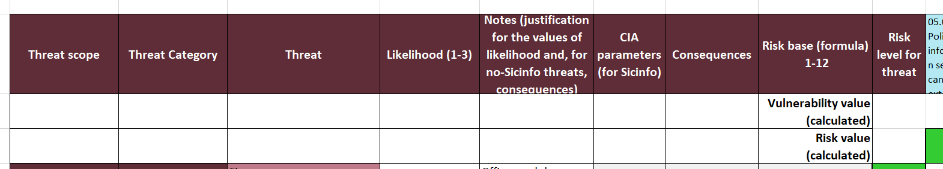

  - Correlate controls to the new threat, copying another cell where appropriate at threat-control intersections.

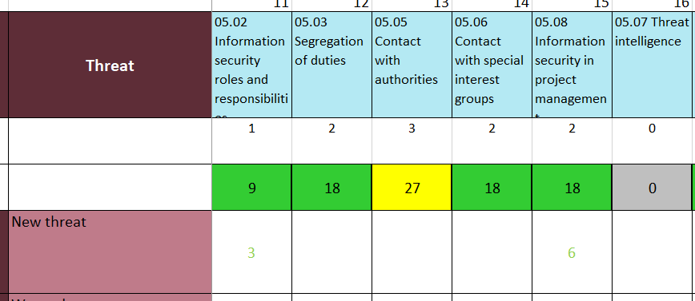

For those who use the "Privacy risk" tab, the same lines should be added with the following precautions:
- in the "privacy Risk" tab,
  - a row needs to be added;
  - the Scope, Category and Threat fields must be filled in manually by copying from the "Threats - Risk" tab;
  - the "Privacy Risk" fields should be selected as appropriate.
  - the other fields should be filled (with formulas) copying the cells from the previous or next row.

Calculation of the risk level

Description of the calculation
Each control has a vulnerability value associated with it (see section 2.3). The value, transcribed in the row below each control, is indicated as
vlb.

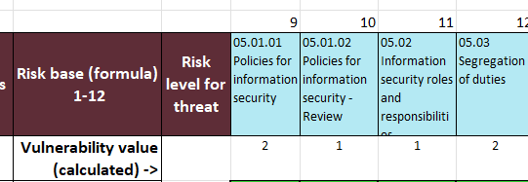

The level of risk associated with each pair (threat, control that counteracts it) is calculated with the following calculation:

Current risk = MAX (Cxc, Ixi, Axa) ∙ t ∙ vlb

Each risk triplet therefore has values between 1 and 48.

For each control, the associated risk level can be derived by calculating the MAX of the relevant pairs (threat, control).

Similarly, the level of risk associated with each threat can be derived by calculating the MAX of the relevant pairs (threat, control).

Risk acceptance criteria (proposal)
The following table and criteria are examples and can be changed as needed.

Risk level
Low < 20
19 < Medium < 41
High > 40

Risks less than 20 are automatically accepted.

Risks above 20 must be analysed in order to identify explicit treatment options (including the acceptance).

Acceptance can be based on the following:
- there are enough compensating controls (in this case, the risk should be re-calculated in the tab "Risk treatment - proposal" writing on column "Expected control value after treatment (WRITE ONLY IF IT CHANGES)" and the reason;
- other strategic choices don't allow mitigation actions;
- the cost for mitigation actions (e.g. new or improvement of controls) will be so high that benefits are not clear;
- mitigation actions (e.g. new or changed controls) will introduce unacceptable new vulnerabilities or ineffective practices (.e.g. employees don't accept or correctly implement the changed control).

It is not possible to accept high risks (i.e. they must be mitigated at least to a medium level), except when there are enough compensating controls that reduce the risk to a medium level.

Treatment options, including acceptance ones, must be approved by top management.

Identification and evaluation of controls
In the "Controls and SOA" tab, the controls must be evaluated.

Control fields
The fields are as follows:

- Old versions: the numbers from the previous versions of ISO/IEC 27001, ISO/IEC 27017, ISO/IEC 27018. For new controls, the number is the one for having the new controls near similar ones.

- ISO/IEC 27001:2022 control: Some of them have been split into sub-controls partly because I prefer to keep them visible, as they are important, partly for a better cross reference with Impl. Guid. and NIST CSF 2.0 measures. They can be deleted without impacts on ISO/IEC 27001 conformity.
  - after ISO/IEC 27001 controls there are ISO/IEC 27701:2025 (Final draft), ISO/IEC 27017:2026 (Draft of March 2025) and ISO/IEC 27018:2025 (Final draft) controls and HLS requirements.
- Measures of the European commission Implementation regulation 2024/2690 (number and title, number and text) and NIST CSF 2.0.
- Control evaluation: (1-4) [mandatory field]: value from 1 to 4, to be assigned according to the criteria in the "Evaluation criteria" tab, under the heading "Criteria for the evaluation of information security controls" (they can of course be modified according to needs).
- How the control is implemented: A field in which to detail how the control is implemented, reference documents, etc.
  - I included some considerations of mine and if ISO/IEC 27017, ISO/IEC 27018 or ISO/IEC 27701 have additional implementation guidelines.
- Deficiencies: if there are deficiencies, write them here; if the control does not have value 4, this field should be filled (moreover, if third parites require a copy of the SOA, you may find convenient to omit this column);
- Documents: documents relevant to the control;
- Responsible persons: persons responsible for the control (design and operation);
- Reasons for inclusion (Risk assessment, Laws & reg., Contracts): for ISO/IEC 27001, the reasons for the inclusion of a control shall be indicated. Risk assessment is always an applicable reason.
- Ev. of VULNERABILITY (calculated): if a control has a maximum value (4), its vulnerability is minimum (1); If it has a value of 3, its vulnerability will be 2, and so on. So the formula is:

vlb = 5 – control - evaluation

- Applicability: pre-filled indicating the control categories (with some freedom) of ISO/IEC 27002:2013. I use it to indicate in which organizational area the control should be analyzed (and also audited). In a simpler company, there may be few areas (e.g.: IT service management for customers, internal IT, government, software development); in a more complex one they can be more.

Criteria for the evaluation of information security controls (proposal)
The following table is an example and can be changed as needed.

Lev. | Guidelines for evaluation
1 - Non existent control | The control is not implemented.
2 - Low effective control | The control is not systematically implemented or it is completely not suitable, so its effectiveness is not ensured.
3 - Almost effective control | The control can be improved, mainly from a procedural (i.e. support documentation) point of view.
4 - Effective control | The control is systematically implemented and no improvement are needed.

Adding a control
- In the "Controls and SOA" tab:
  - add a line where appropriate (the choice of where to insert the control depends on your needs, how convenient it is, etc.);
  - enter the title of the control in the column "ISO/IEC 27001:2022 Control";
  - fill the other rows as much as needed;
  - evaluate the control (Excel should have already formatted the cell with the default list; if not, copy from the previous line);
  - check that the column " Ev. of VULNERABILITY (calculated)" is automatically filled in (Excel should have already formatted the cell with the default list; if not, copy from the previous row).

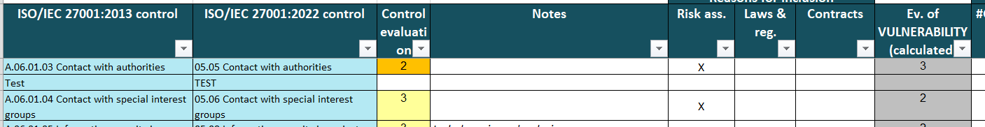

- In the "Threats - Risk" tab:
  - add a column where needed (you can copy and paste a column of a similar control, in order to copy also the links with threats);
  - copy the exact title of the control in the column header;
  - Relate control to threats.

- In the “Risk treatment-proposal" tab:
  - add a line (even in a random place), copying a line above or below;
  - copy precisely the cell "ISO/IEC 27001:2022 Control" from the "Controls and SOA" tab;
  - the rest should fill in automatically.

Risk treatment
VERA offers risk acceptance criteria in the "Evaluation criteria" tab, under the heading "Risk acceptance criteria" (they can of course be modified as needed).

In the "Risk treatment-proposal" tab, you can sort the controls according to the associated risk.

In the book "Information Security" it is described why it is useful to think by the level of risk associated with control and not the level associated with the threat. This approach is shortly described in the Introduction of this booklet.
Permette di ordinare dal rischio più alto a quello più basso.

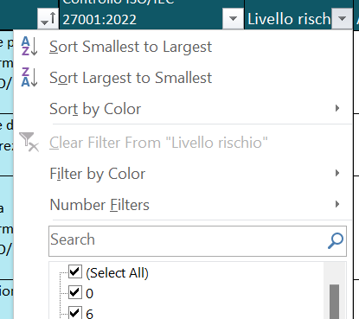
This orders risks from the higher to the lower.

The fields are as follows:
- ISO/IEC 27001:2022control : please note that the cell must be the same as the one in the "Controls and SOA" tab (otherwise the calculations will not be correct).
- Risk Level: The value comes from the "Threat - Risk" tab ("Risk value for control (calculated)" row).
- Analysis: to be completed when a risk is not low (low risks, i.e. green risks, are implicitly accepted and do not require further analysis). You should copy and paste here the “Deficiencies” in the “Controls and SOA” tab.
- Actions: to be filled in to indicate what actions (mainly acceptance or mitigation) you want to take for non-low risks. For each action, the person responsible and the deadline must be indicated (columns can also be added for this and other data. My approach: I describe the action, together with the corrective actions and improvement actions determined by other analyses, in another sheet with the following fields: Action, Deadline, Closed on, Verified by, Progress notes, Evaluation of the effectiveness of closure, Open or closed).
- Owner: person responsible for the implementation of the proposed actions.
- Deadline: date when the proposed actions should be completed.
- Initial control evaluation: not to be changed and taken from the "Controls and SOA" table.
- Expected control value after treatment (1 to 4): to be entered only if you plan to change (usually improve) the control to reduce the level of risk.
- Expected residual risk level: A calculated field that indicates the expected level of risk after the control change action.
- Level or risk changed?: field to cross-check calculations.

Periodic review

The review necessarily requires to copy (and paste) the VERA sheet.

It is possible to indicate changes in the notes fields using standard wording (e.g. "UPDATE 2025") or by highlighting the cells where appropriate.

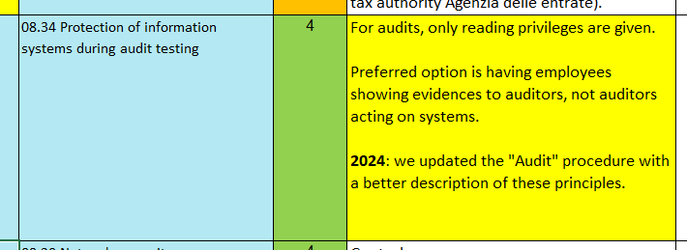

Privacy

The "Privacy Risk" table is used to demonstrate how the threats in the "Threats - Risk" tab cover the threats under the GDPR ("Unauthorized destruction", " Unauthorized loss", “Unauthorized alteration", " Unauthorized disclosure", “Unauthorized access to data transmitted”, “Unauthorized access to data stored”) and allows you to view the risk level for each threat.

The tab can also be used for PIA (or DPIA). It allows you to see if there are any "pure" risks, i.e. "in the absence of measures", high, i.e. highlighted in red. The GDPR sets out what to do in the event of a "high risk in the absence of measures".

Procedure to describe the approach

To meet the requirements of ISO/IEC 27001 you may need to have a procedure that describes your approach to risk assessment.

You can refer to this manual.

However, the following details should be added, possibly in other documents, related to this one:

- when conducting the information security risk assessment (usually "annually or on the occasion of significant changes");
- Who is responsible for the activities:
    - who identifies individuals to identify and evaluate information;
    - who identifies and evaluates the information and related assets;
    - those who identify and assess threats (involving others, if necessary);
    - who assesses the controls (involving others, if necessary);
    - who proposes risk treatment options;
    - who approves the treatment of the risk (and therefore the residual risk).

ISO/IEC 27001 refers to "risk owners", in line with ISO 31000. It should be remembered that usually, and considering the terms of the management systems standards, this role is covered by the top management, which in turn relies on the indications of their co-workers.

